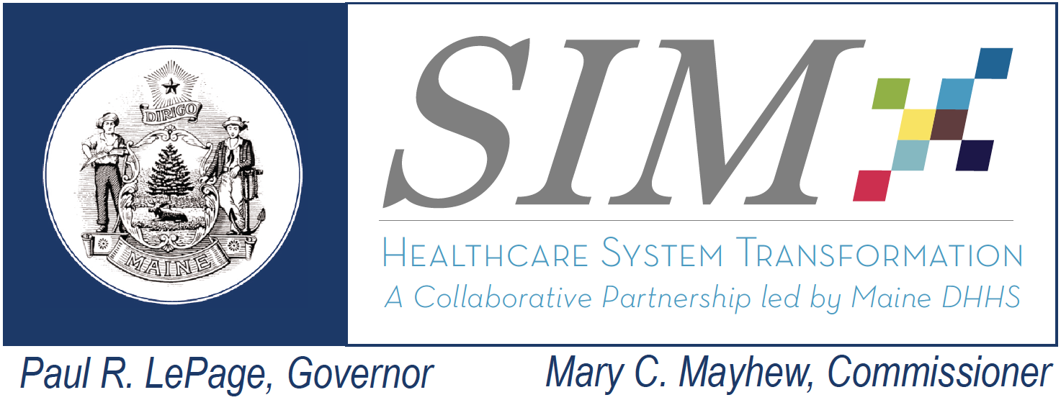 |  | SIM Steering Committee Meeting  January 15, 2016 10:30 AM – 11:30AM  DHHS 221 State Street. Main Conference Room  Conference Call #: 1-571-317-3131  Conference Code: 325-368-269  Webinar Link: https://global.gotomeeting.com/join/325368269
Topic | Lead | Objective and Planned Highlights of Discussion | Estimated Time
1- Welcome | Randy Chenard |  | 5 minutes  10:30 – 10:35
2- SIM Objective Review | Stefanie Nadeau | Objective: Review Maine Leadership Team decisions regarding the Strategic Objective Review Team and discuss key next steps for SIM program | 45 minutes  10:35-11:20
3- Public Comment |  |  | To begin no later than 11:20

